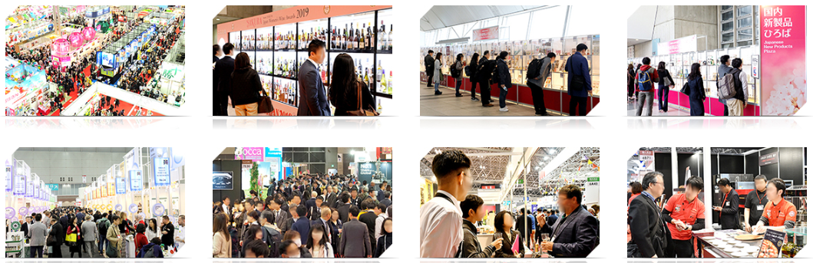

APPLICATION FORM
Agrofood
Sector Group

TRADE MISSION TO JAPAN
for EU Organic Food&Beverage SMEs

at Foodex Japan
8-14 March 2020
Closing Date for applications: 12 July, 2019

to
Giada Platania, Head of the International Affairs Unit
Via A. Volta 44 – 90133 Palermo
T: +39 091581100
E: een@sicindustria.eu

1. I wish to apply for the European Company Mission to Japan

2. I have read and agree to Sicindustria Terms and Conditions for this mission.

Title: First Name: Surname:
Company Name: Position:
Address:
Country:______________________________________________________________________
State/province: ________________________________________________________________
City: _________________________________________________________________________
Postcode:
Telephone: Mobile:
(Only the Event Organisers can see your phone numbers)
Fax Email:
Website:
Business Sector:
Print name: Signed

Date:

COMPANY INFORMATION

VAT Number:
Year Established:
Number of Employees:
Annual Turnover:

Company Representative on the Mission (if different from the above):
Name:
Position:
Tel: Fax:
Email:
Website:

Second company representative on the Mission:
Name:
Position:
Tel: Fax:
Mobile:
Email:
Mobile: Website:
Only two representatives per company are allowed.

Passport Information (first participant)
Name (as in Passport):
Date of Issue:
Date of Passport Expiry:
Passport Number:
Date of Birth:
Country of Issue:

Passport Information (second participant)
Name (as in Passport):
Date of Issue:
Date of Passport Expiry:
Passport Number:
Date of Birth:
Country of Issue:

Complete your profile
Add information about you and your organisation to your profile so that participants can get a better understanding for what you are looking for and can offer.

Profile Picture
Add your personal picture in attachment
Use a picture that gives the attendees a good impression of who you are.
No logos or pictures of landscapes, please.
Organisation Description
Write a short description of what your organisation does.
Keep it clear, not too short, appealing, and enjoyable to read.
This is the way your potential partner will be able to see what you do.

Organisation Logo
Attach your organisation's logo. It will be visible inside your profile.

Areas of Activity *
Areas of Activity help us to categorize what you do and offer.
This makes easier for other participants to find you and makes your profile more expressive.

Please select areas of activity that suits your profile:
Supermarket
- Sweets, chocolates and candies
- Meat
- Seafood
- Pasta
- Rice and Beans
- Cocoa, cocoa powder, cocoa solutions
- Oils, Sauces, Salad Dressings and Condiments
- Cereals and breakfast foods
- Soups and Canned goods
- Frozen foods
- Dairy, Cheese and Eggs
- Biscuits, Cookies, Snacks and Crackers
- Drinks
Gourmet products distributor
- Cheese
- Charcuterie
- Foie Gras
- Baking and pastry
- Chocolates
- Pantry
- Oil and Vinegar
- Spices and condiments
- Truffles and Mushrooms
- Seafood
- Wine Beer Spirits
HORECA (hotels, restaurants and catering)
- Bakery
- Seafood
- Meat
- Poultry
- Potato
- Dairy
- Dry food
- Pasta
- Sauces & Condiments
- Savoury Solutions
- Sweet Solutions
- Desserts
- Still Water
- Sparkling Water
- Beverages Solutions
- Juices

Fresh
- Fruit
- Vegetables
- Frozen food
- Organic
- Healthy

Your offer/request
Add and describe one (or more) product/service/partnership/investment

NEW PRODUCT
Product
Add and describe a product you are offering to your profile

Title(max 160 characters):

Description (make your description clear and appealing):

What are you looking for? Please, select
- Distribution Partner
- Exporter
- Wholesaler
- Importer
- Suppliers
- Other (specify): _________________

Market application keywords
- Food and Beverage
- Gourmet market for food and beverage
- Food and Beverage for HORECA
- Supermarkets
- Fresh food
- Non-Alcohol drinks
- DairyBakery
- Wine
- Oil

